Katrine Stelges Finalist for Outstanding Woman Engineer of the Year Award
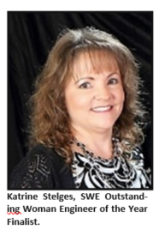
She may not have won it - this time - but TOSC’s Katrine Stelges was nominated for one of the event’s most prestigious awards as the Space Coast Section of the Society of Women Engineers (SWE) held its annual Women Engineer of the Year Awards Banquet Tuesday, March 12, 2019 in Viera, FL.

Katrine, a Senior Lead Engineer / Project Manager for the Human Factors / Industrial Engineering organization, was among a dozen finalists for the Space Coast Outstanding Woman Engineer of the Year Award.

A certified Lean Six Sigma Green Belt, Katrine has twenty-two years of engineering experience supporting NASA’s Ground Systems development, launch operations, flight hard- ware processing and ground systems capabilities. A renowned subject matter expert in Human Factors / Industrial Engineering, Katrine has published numerous papers, been featured in NASA’s Engineering & Safety Center Technical publication, and continues to support out- reach such as KSC’s annual Community Day and Safety Week events.

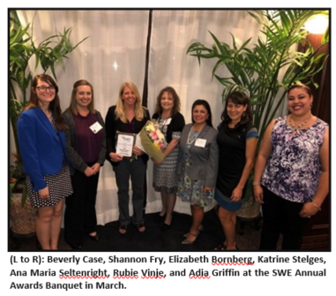
Katrine has received numerous awards throughout her career, including NASA’s prestigious Space Flight Awareness Award in 2006 and other NASA Group Achievement Award recognitions. She has also received TOSC’s Safety, Health and Environmental Champion Award in 2017, Director’s Team Award in 2015, and Director’s Individual Award in 2014.

Founded in 1978, the Space Coast Section of the SWE serves engineers in Brevard, Indian River, and Volusia Counties. Its mission is to “inform the community of opportunities open to women in engineering and to encourage women to enter and grow in engineering and the sciences.”

