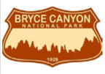
TOSC Manager Ellen Brown Promotes
Aerodyne in the Great Southwest

So what did you do on your summer vacation?

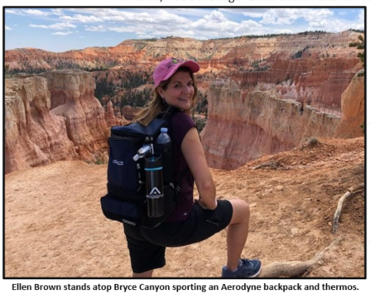
While many of us probably beat the heat while watching reruns of Game of Thrones, TOSC Manager Ellen Brown and her family were scaling mountain ranges in the great southwest. Ellen, husband Dave (who is a Manager for Jacobs/TOSC), and son Mitchell, a recent high school graduate, scaled Bryce and Zion Canyons in Utah and enjoyed a helicopter ride over the Grand Canyon and Hoover Dam on the border of Arizona and Nevada.

Ever the wise traveler, the Georgia Tech alum was outfitted smartly with Personal Protective Equipment like an Aerodyne thermos and backpack and Jacobs hand sanitizer.

