Six Orion Software Teammates
Receive Team Excellence Awards

Bob Hafernick, Cassandra Jackson, Steven Kipp, Tony Tran, Phil Trottman and Mark Wiederholt honored

Six Orion Software Teammates were recently honored with Excellence Awards for their outstanding work in leading and supporting the development, installation, configuration, and activation of the first Exploration Mission (EM)-1 Training Simulator on the Orion and Space Launch System project: Mark Wiederholt, Phil Trottman, Bob Hafernick, Cassandra Jackson, Steven Kipp and Tony Tran.

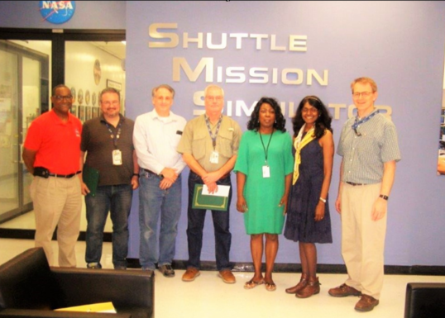

(L to R): Matt Bogues (TS21 Manager), Phil Trottman, Mark Wiederholt, Bob Hafernick, Cassandra Jackson, Geetha Alagappan (MSOC Teammate Principal), and Randy Saint, TS21 Manager. Not Pictured: Steven Kipp and Tony Tran.

