TOSC Engineer Merritt Robbins a
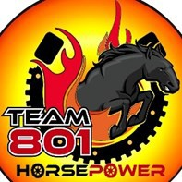

FIRST Class Mentor

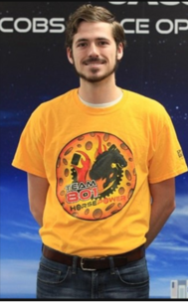
Merritt Robbins, an Electrical Engineer for TOSC, is a self-confessed nerd when it comes to science and engineering. “Come talk to me about alternative or perpetual energy, the future of manned and unmanned space-flight, or anything related to science and engineering,” he said.

When Merritt, who joined Aerodyne in March 2017, is not busy building the world’s most powerful rocket for the Space Launch System (SLS) Program, he is mentoring a FIRST Robotics team. FIRST (For Inspiration and Recognition of Science and Technology) was founded in 1989 to inspire young people's interest and participation in science and technology. FIRST Robotics Competition (FRC) combines the excitement of sport with the rigors of science and technology. Competitors call it the “hardest fun you’ll ever have.”

CEO Andy Allen, who retired from NASA on Oct. 1, 1997 to become President of the FIRST Foundation, has a unique perspective from his two-year stint in charge of the non-profit organization.
“I know first-hand the impact FIRST has on students and I am extremely proud of our mentors and the life changing impact the competition and mentors can bring to high school students,” Andy said. “It’s a great place to demonstrate where engineering and science can be fun.”
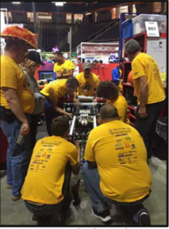
Merritt is one of two TOSC mentors that guided Team 801, Horsepower, which is comprised of stu- dents from four schools located on Florida’s Space Coast: Merritt Island High School, Merritt Island Christian School, Edgewood Jr./Sr. High School and Cocoa Beach Jr./Sr. High School.

This is the second year mentoring for Merritt, who graduated from the University of Central Florida in 2016. “This year’s game was exceptionally diverse, and the number of systems required to solve all problems presented was significant,” said Merritt. “The design and operation- al engineering challenges posed gave a sense of urgency and determination to get as much done as possible within the significant constraints provided.”
After a disappointing performance at the 2019 Orlando Regional in March 2019, Team 801 rebounded two weeks later at the Smoky Mountains Regional in Knoxville, TN. Thanks to some last-minute software adjustments and drivetrain tuning, Team 801 showed tremendous improvement and placed 35 out of 51 teams.

“The robot’s functionality was good, and the operation was so fast the learning curve to managing the speed was steep and time offered for practice was severely limited,” Merritt said. Team 801 Horsepower looks forward to the 2020 season with great anticipation of the challenges to come.”

As FIRST celebrates its 30th Anniversary, it continues to inspire young people to reach for the stars, thanks to passionate mentors like Merritt. "The experience of mentoring an FRC team is challenging, but rewarding,” he said. “Working with high school children in such a difficult engineering endeavor is inspiring and reminds me of the creativity which should be applied to all engineering solutions.”

